**Setting Up Application**

**Environment**

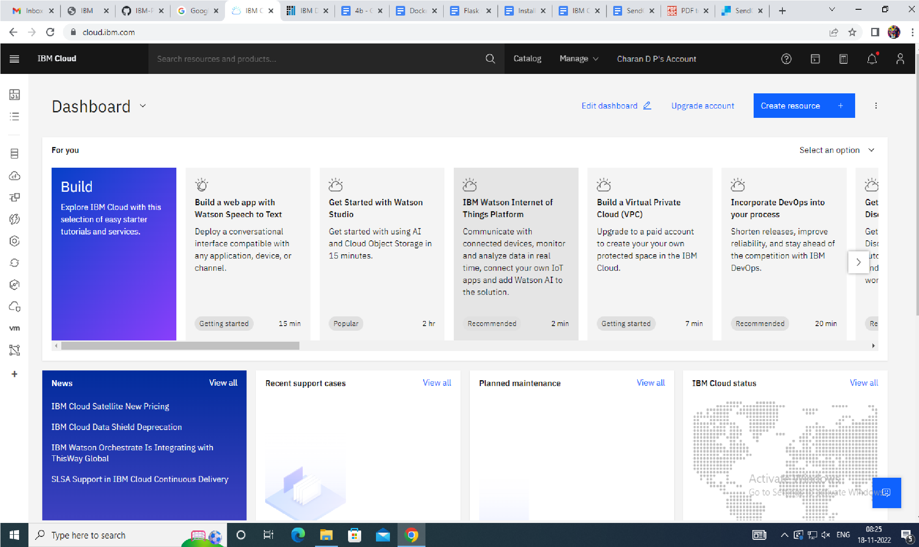**Create IBM Cloud Account**

|  |  |
| --- | --- |
| Date | 10 Nov 2022 |
| Team ID | PNT2022TMID11845 |
| Project Name | Smart Fashion Recommender Application |

**IBM Cloud Login**

**IBM Cloud Account**

